**BSc (Hons) in Information Technology**

**Software Engineering – Year 3 Semester 2, 2022**

**SE3050 – User Experience engineering**

**Milestone 02**

**Team BIKO - SER_027**

IT20070458 O.K Wijewardena

**Table of Contents**

Table of Contents

**Goal3**

**Research questions** **3**

**Method**

**1. Interviews4**

**2. Video Recordings5**

**3. Questionnaires6**

**Participant Profiles11**

**Prototype 12**

Goal

According to my persona, making the financial platform of the factory stronger and safe is my main goal. To achieve this goal, I want to plan user research to clearly understand the experience that the user is getting usually. Therefore, I am going to find the details regarding the current safety precautions that are taken to protect finance data and the details about the external parties related to finance that they get help from, through this user research for my persona.

Research Questions

How to gain acknowledgement of Tea Harvest prices according to the market.

How to give awareness to the tea sellers about the market price

Way that calculating the payment according to the seller harvest

How to take financial decisions

Method

* Interviewing

|  |
| --- |
| * Hi, how are you doing today? * Thank you for lending your valuable time for us today! * We will start with some questions, so please share your honest thoughts as we go along. There are no right or wrong answers. * Do you have any questions for me before we get started? * Before we begin could I just confirm that you are still okay with this session being recorded and shared * with our module in charge? [wait for reply] * Ok. I will start the recording now.[PRESS RECORD]   (හායි, අද ඔබට කොහොමද?  ඔබගේ වටිනා කාලය අද අප වෙනුවෙන් කැප කිරීම ගැන ඔබට ස්තුතියි!  අපි ප්‍රශ්න කිහිපයකින් ආරම්භ කරන්නෙමු,  කරුණාකර ඔබේ අවංක අදහස් අප සමග බෙදා ගන්න  ආරම්භ කිරීමට පෙර ඔබට මගෙන් ප්‍රශ්න ඇසිමට තිබේ ද  මෙම සැසිය පට්ගත කීරීම සම්බන්ධයන් ඔබට ගැටලුවක් තිබේ ද?  එසේනම් අපි සැසිය ආරම්භ කරමු.)   * When did you join this tea factory? ( ඔබ තේ කරන්තය සදහා එකතු වුයේ කෙසේද?) * If you don’t mind, could you please briefly tell us where have you work before joining this factory? ( ඔබට ප්‍රශ්නයක් නැතිනම් කරුණාකර මෙම කර්මාන්ත ශාලාවට සම්බන්ධ වීමට පෙර ඔබ රැකියාව කළේ කොහේදැයි කෙටියෙන් අපට පැවසිය හැකිද?) * As the finance manager, are you the one who is responsible for handling the payments for the tea sellers and other employees? (තේ අලෙවි කරන්නන් සහ අනෙකුත් සේවකයන් සඳහා ගෙවීම් කටයුතු කිරීමේ වගකීම මූල්‍ය කළමණාකරු ලෙස ඔබ සතුද??)   + If yes, are the payments finalized weekly or monthly? (ඔව් නම්, ගෙවීම් සතිපතා හෝ මාසිකව අවසන් කර තිබේද?)   + If not, what is the task you have to handle in the factory? (නොඑසේ නම්, කර්මාන්තශාලාවේ ඔබට කළ යුතු කාර්යය කුමක්ද?) * Do you get help from any smart devices to proceed with the payment calculations? (ගෙවීම් ගණනය කිරීම් ඉදිරියට ගෙන යාමට ඔබට කිසියම් ස්මාර්ට් උපාංගයකින් උදවු ලැබේද?)   + If yes, what are the devices used? (ඔව් නම්, භාවිතා කරන උපාංග මොනවාද?)     - Do you trust the results you get from those devices? (එම උපාංගවලින් ඔබට ලැබෙන ප්‍රතිඵල ඔබ විශ්වාස කරනවාද?)       * If not, what is the reason? (එසේ නොවේ නම්, හේතුව කුමක්ද?)   + If not, how do you proceed with the calculations? (එසේ නොවේ නම්, ඔබ ගණනය කිරීම් ඉදිරියට ගෙන යන්නේ කෙසේද?)     - Do you trust the results you get from those devices? (එම උපාංගවලින් ඔබට ලැබෙන ප්‍රතිඵල ඔබ විශ්වාස කරනවාද?)       * If not, what is the reason? (එසේ නොවේ නම්, හේතුව කුමක්ද?) * How do you give awarness to the sellers about the tea price range (තේ මිල පරාසය ගැන විකුණුම්කරුවන්ට ඔබ දැනුවත් කරන්නේ කෙසේද?) * Are there any external parties who help in the payment process? (ගෙවීම් ක්‍රියාවලියට උදව් කරන බාහිර පාර්ශ්ව තිබේද? |

* Video recording

Link: https://drive.google.com/drive/u/0/folders/1IsT5lM-f4yqEdf6N29uuMOGUJKazK66_

* Questionnaire

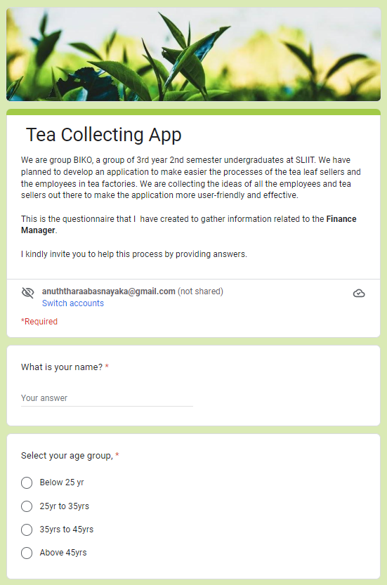

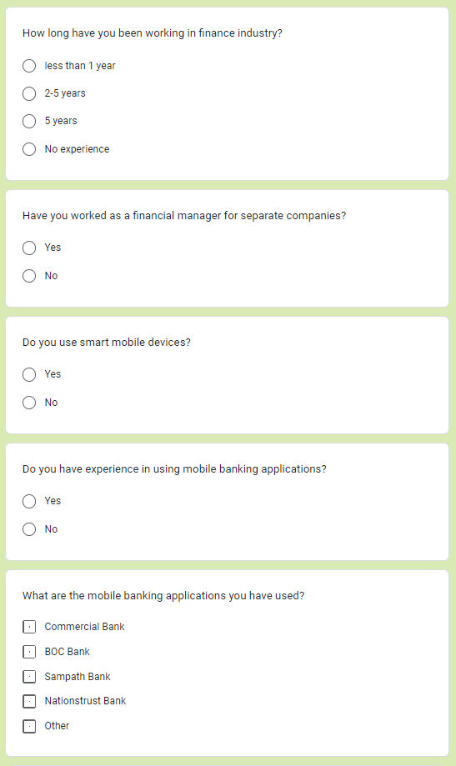

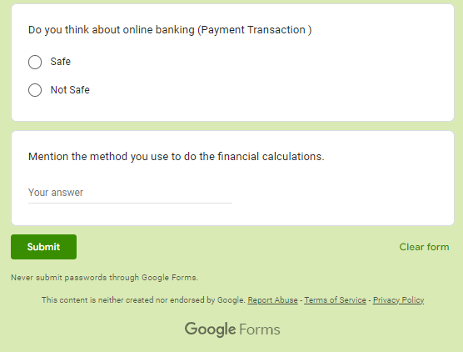

Responses:

Participants

|  |  |  |
| --- | --- | --- |
| Name | Demography | Location, Date and Time |
| Mr. Milinda Senavirathana | **Age:** 31  **Gender:** Male  **Marital Status:** Married  **Location** Sri Lanka  **Profession:** Finance Manager | **Location:** Wilpita  **Date:** 2022/Sep/26  **Time:** 09.30 am |

Protocol

The user research was planned to be conducted as a user interview session. We found real users (Physical Mode) who match with my personas and decided to meet them in their real environments. I have selected a Financial Manager who lives in a Wilpita, which is in the date we planned to do the interview was 26th September 2022.

When conducting the interview, due to the request of the person I had to conduct the meeting via physically. As my persona is related to a Finance Manager, I have met Malinda Senevirathna who is a Finance Manager.

I wanted to find out how they notify sellers of prices and how they determine total prices. My goal is to use those specifics to create a service that assigns prices to sellers and performs system calculations.